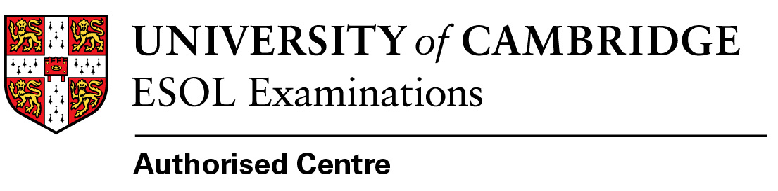
Please fill in the form electronicaly and return by email to exams@balticcouncil.org :
Exam | Exam date |  | Registration deadline | Fee EUR | Please indice by ✓ which test you want to take
BMAT- paper based test | 18-October-22 |  | 29/09/22 | 120
TMUA-paper based test | 18-October-22 |  | 29/09/22 | 60
ENGAA-paper based test | 19-October-22 |  | 29/09/22 | 60
NSAA-paper based test | 19-October-22 |  | 29/09/22 | 60
CAT-paper based test | 2-November-22 |  | 29/09/22 | 60
MAT-paper based test | 2-November-22 |  | 29/09/22 | 60
MLAT-paper based test | 2-November-22 |  | 29/09/22 | 60
OLAT-paper based test | 2-November-22 |  | 29/09/22 | 90
Oxford ELAT-paper based test | 2-November-22 |  | 29/09/22 | 60
HAT-paper based test ed test | 2-November-22 |  | 29/09/22 | 60
PAT-paper based test | 2-November-22 |  | 29/09/22 | 60
Philosophy Test-paper based test | 2-November-22 |  | 29/09/22 | 60
TSA - paper based test | 2-November-22 |  | 29/09/22 | 60
TSA-S1 - paper based test | 2-November-22 |  | 29/09/22 | 60
Name and Surname
Date of Birth
UCAS registration number
Name of University where you apply
College where you apply
Course name & number
Home address
Phone number
E-mail address
If you have any special needs (health problems) If yes the medical certificate in English should be attached and the registration form should be returned by 15 September 2022 |  | Yes No
Date of application
Bank details:
Account holder: Baltic Council for International Education
Registration Nr: 40008085919
Account numbers: LV20HABA0551019935194
Bank name: SWEDBANK HABA LV 22
Payer info: Admissions tests 2022 + your Name & Surname

